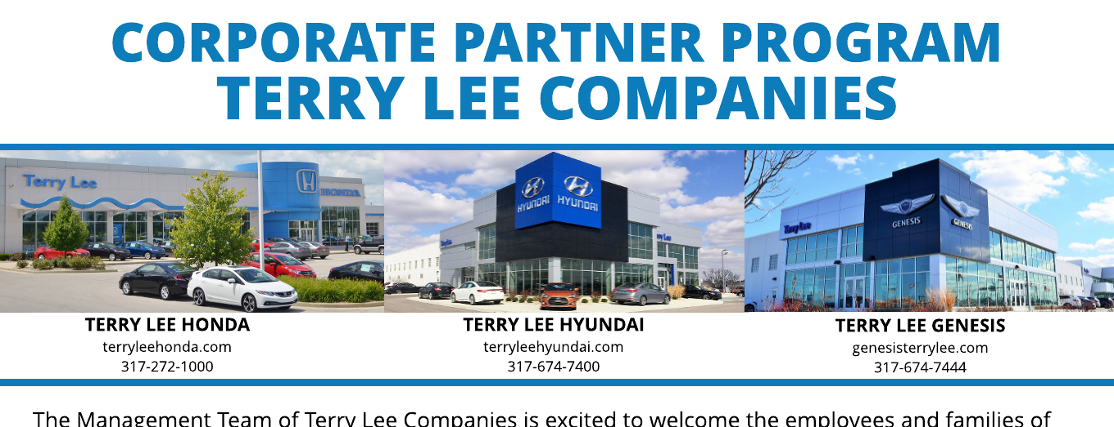

The Management Team of Terry Lee Companies is excited to welcome the employees and families of the MSD of Decatur Township into our Corporate Partner Program.

This Program is designed to make your customer experience as straight forward, easy and as inexpensive as possible by providing you, your employees and families a consistent, competitive pricing structure in a world-class service environment.

**Employee Pricing on New Honda, Hyundai & Genesis Vehicles**

The majority of our new vehicle inventory will be offered to you at Manufacturer’s Invoice with minor exceptions such as new model introductions, newly redesigned models, vehicles in extremely short supply, etc.

You will receive all consumer incentives from the Manufacturer in effect at time of purchase/lease. These incentives will be used to reduce your purchase price and often result in a price well below dealer invoice, the price we pay for the vehicle from the Manufacturer. Corporate Partner Purchase Procedures must be followed to be eligible for discounts.

**Employee Pricing on Pre-Owned & CPO Vehicles**

All Pre-Owned vehicles are priced independently because they are all different manufacturers, makes, models, trim levels, etc.

**Parts, Service & Aftermarket Accessories Discounts**

You will receive a 10% discount on all parts, service & aftermarket accessories purchased at our dealerships. This Certificate must be presented to the Service Writer at time of service to be eligible for these discounts. Discounts cannot be combined with other offers and are subject to a $100 maximum per visit. Please note that our manufacturer trained technicians service most makes and models of passenger vehicles sold in the US.

**Corporate Partner Program Procedures for Vehicle Purchases:**

**Please contact Gary L. Weber, Corporate Partner Program Manager, at (317) 833-7065 or gweber@terryleehonda.com to ensure exclusive pricing before visiting the dealership.**

**EXPLANATION OF BENEFITS:**