6th Grade High Ability Showcase Presentation

6th grade students were challenged to create a bridge that could withstand an earthquake and a large load. In order to meet this challenge, students brainstormed questions, researched the pros and cons of the different types of bridges, and decided on a bridge to create.

Individually, students designed blueprints of their bridges. After creating individual bridge designs the students were placed into small groups. The groups then worked together to create one superior bridge with the best features from the individual designs.
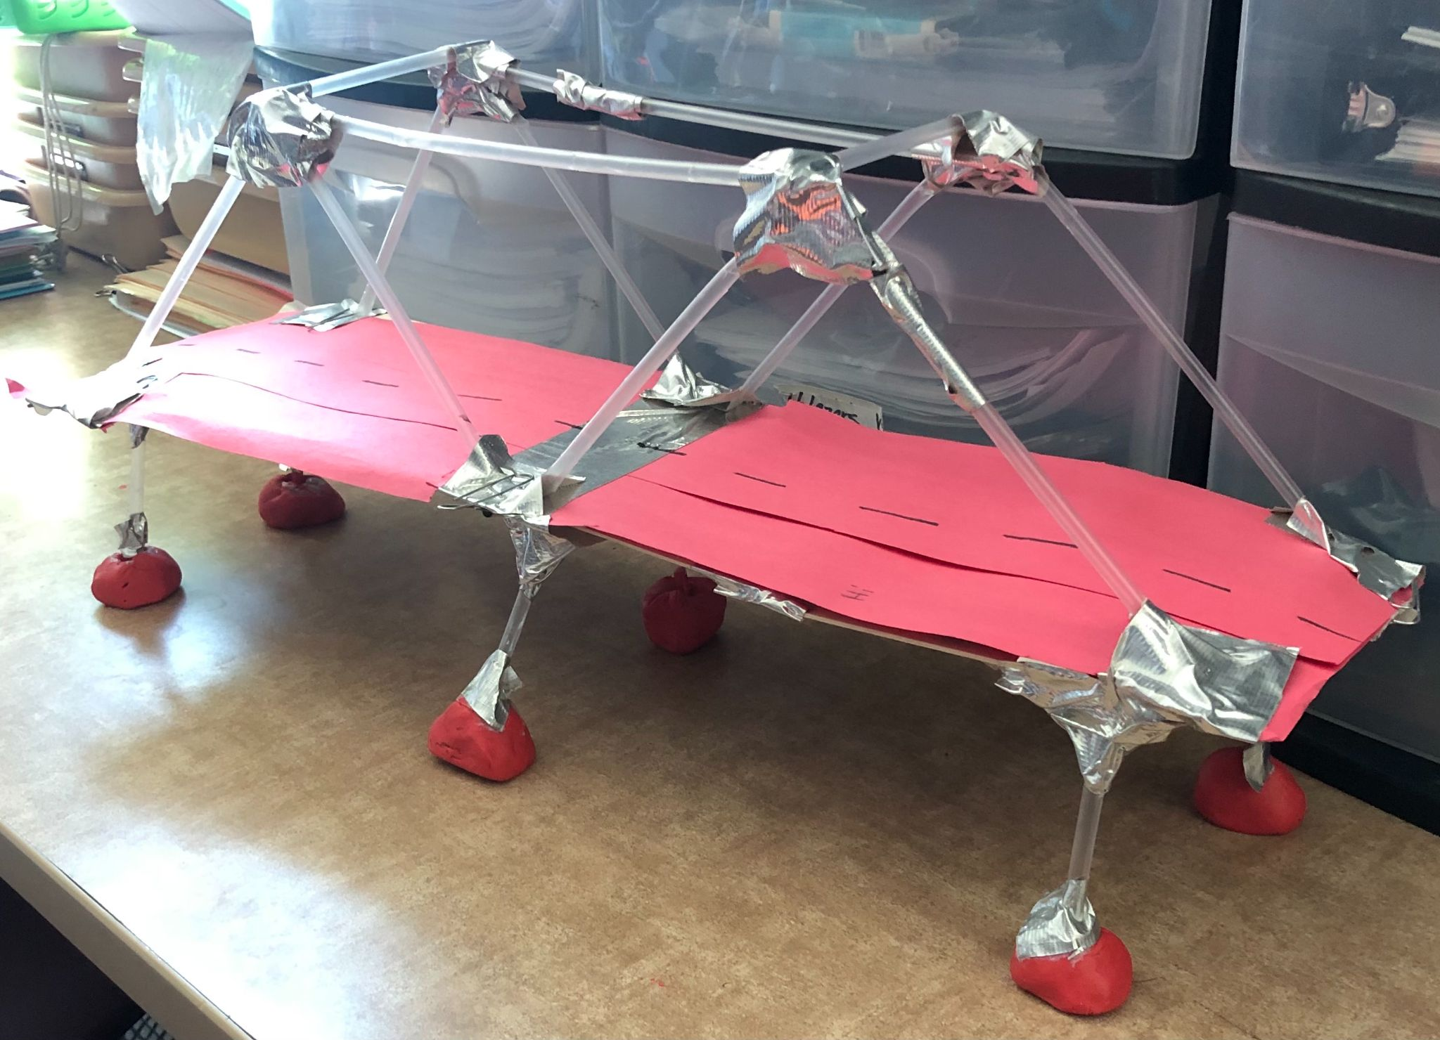
An earthquake was simulated to test the bridge and weights were used to decide the loads the bridges could handle. These tests determined if the bridges were structurally sound.

Who's bridge survived?

To view the students’ presentations, please click on the link below:

https://info.flipgrid.com/
class code=mcgathey8551
Student name= Gold Academy

