EDGE Academy
School of Media Arts and Communications
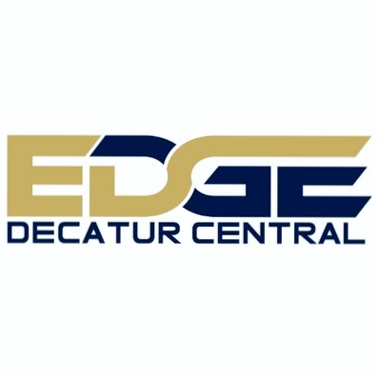
MDS Decatur Township Mission and Vision

Mission
The MSD of Decatur Township is Student Invested, Community Connected. We prioritize Student Learning, Safety and Customer Service, fostering a support system for our families.

Vision
Learning Pathways for individual aspirations is an ever-changing World.

Belief Statement
A focus on student learning is essential for all of our children as we empower growth and development through a high level of expectations well beyond high school graduation. MSD of Decatur Township Graduates is prepared to achieve their life goals that they have developed through a focus on college and career readiness during their time at the MSD of Decatur Township.

Decatur Central High School Mission
DCHS will produce CCR graduates, prepared for the 21st Century global economy, by being student-invested and community-connected.

The EDGE Academy Mission and Vision
Mission
The EDGE cultivates 21st century citizens who excel in media arts by developing and adopting the 5 pillars of communication: Digital & Print Media, Broadcast, Graphic Design, Photography and Public Relations.
Vision
Our Vision is to develop all EDGE graduates with the skills and knowledge to document, prosper and impact our ever-changing world.

Introduction

The Edge Academy is one of the 5 small learning communities at Decatur Central High School. Edge is the community of media arts and communication. Students from the EDGE meet common 40 requirements, with the 5 pillars of Communication:
- Digital & Print Media
- Broadcast
- Graphic Design
- Photography
- Public Relations
Through a collaborative effort we have developed a strategic plan to engage, re-focus and inspire our community to build on our mission and goals so that our small learning community will continue to thrive.
These goals are separated into interrelated areas that really shape and define who we are as a learning community: literacy, technology, communication, presentation skills and building personal brand. Our strategic plan breaks our goals into 3 broad categories of focus:
- Academic Programs and Quality of Instruction
- Student Success
- Student Profile and Brand

Area of Focus
Academic Programs and Quality of Instruction
The Edge Academy will create learning opportunities that are rigorous, integrate technology, reading and writing across the curriculum, and college and career readiness skills.
Key Strategies:
- Utilize Smekens literacy strategies across the curriculum
- We will create a master schedule that provides cooperative grade/subject planning, create opportunities for planning vertically/horizontally (choosing a natural collaborator partner)
- Create time in schedule for literacy coaching for additional support for teachers and students
- Expand elective options in course master to include marketing class (to build their personal brand), current events (documentary/film)
- Edge students pursuing an academic honors diploma will be encouraged to complete additional AP and dual credit courses
- Utilize the SAMR model to improve instruction through the integration of technology
- We will provide a variety of methods/opportunities for students to present their collections/presentations (use of Stanford rubrics)
- Create a platform to broadcast to DC community to provide quality programing
Area of Focus
Student Success
The Edge Academy will prepare all students to graduate on time
Key Strategies:
- Identify students with special needs and life circumstances and ensure they continue to have access to curriculum and provide support and help them find necessary resources
- Develop a leadership summer program for 9th grade students to recover credits and build success skills
- Enhance on-time graduation support and create opportunities for credit recovery and interventions

Area of Focus
Student Profile and Brand
The Edge Academy will create and sustain a school wide approach to inspire and empower EDGE students to discover and develop their Personal Brand. Students will use their Personal Brand to achieve personal goals with integrity, passion and confidence.
Key Strategies:
- All students will take a semester of marketing and year of Intro to Communications to build personal brand.
- All students will create an electronic portfolio (documentary, film, photography, advertisement, article, cover, radio/TV Broadcast, their senior EDGE Talk etc) that supports their academic achievement.
- We will increase student participation in school/non school based activities including but not limited to (contests, competitions, courses, college exploration, community services, field trips, internships, public events)
- We will provide increased recognition for student accomplishments and participation to these school/non-school based activities (web page, news release, twitter, instagram, newsletter, student spotlight, DCTV & radio broadcasts, EDGE Pillar Awards

Assessment:
For each of the above goals, appropriate leadership will develop specific strategies, benchmark and timelines, and ways to assess. The abovementioned items are just preliminary steps we will be taking to monitor our progress.

