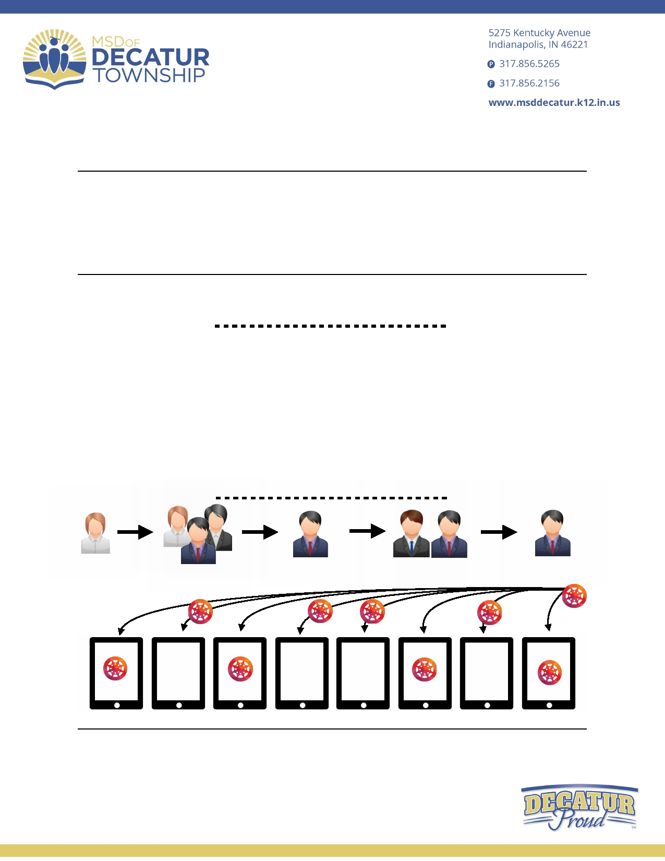DCHS iPad App Request Process and FAQ

Outline
• App Request Process
• App Request Timeline for Deployment
• App Submission Details to Include
• FAQ
App Request Process
This section describes the steps needed to request an application for deployment.
1. Teacher finds an application that they would like students to use on a large scale (SLC wide)
2. Teacher sends this application to their SLC leaders for review and collaboration across the
rest of the teachers contained in the SLC
3. If SLC leaders and teachers confirm they would like this app, then it is passed on to DCHS Principal.
4. Pending principal approval and the proper allotment of funds to the correct VPP account the
the principal will then email Chief Information Officer for final approval.
5. App is then deployed to iPads by System Administrator

Visual representative of the steps above

1. Teacher 2. SLC Approval 3. Admin Approval 4. CIO Approval 5. Tech Deploys App

Canvas

MSD of Decatur Township

App Request Timeline for Deployment
• App request needs to be turned in by Wednesday and will be deployed to the iPads the
following Monday at 11:30 PM.

• Once the principal approves the app and confirms the proper allotment of funds is in the
school's Volume Purchase Program Account, the principal will then send an email to
iPad.Apps@msddecatur.k12.in.us. Only principals have access to send emails to this ac- count.

App Submission Details to Include
• As of writing this, the Apple App Store currently has 1.6 million apps. To confirm the correct
app gets pushed out we need the URL of the app from the iTunes store. Video tutorials are
attached below on how to get this URL. Having the link will minimize any confusion for app
deployment and save valuable time when it comes to collaboration on picking apps to de- ploy.

Video Tutorials
• Get App URL from iTunes on a Mac: View Video
• Get App URL from the App Store on an iPad: View Video
•Get App URL from iTunes on a Windows PC: View Video

Additional Submission Details
• To deploy an app we need the following details:

1. The App URL for the app you would like to deploy
2. Confirm the allocation of app money in the schools Volume Purchasing Program Account
• To get the current amount of money in the schools Volume Purchasing Program Ac-
count, please contact Nicholas Richardson
3. The number of students you want to deploy this app to
4. The total cost of the app licensing
• Contact System Administrator to get the price of the app deployment, higher volumes
change the pricing for select apps.

• For further information, or if you have questions, please contact System Administrator.

MSD of Decatur Township

FAQ
Q. If the student already has the app installed, will this cause there to be two of the same app
on the student's device?
A. No, the iPad is intelligent enough to know when the application already exists on the
device.

Q. Is this process the same for free and paid applications?
A. Yes, we want to keep the same process to reduce any additional complexity.

Q. Can we still tell our class to download a free app if we wish it for a particular class?
A. Yes, this process is for the bulk deployment of applications only.

Q. How long does it take for the application to show up on the student's iPad?
A. This depends on many factors, network speed, VPP account association, etc… If the
students have set up their Apple ID correctly, this process is usually very quick as long as the app was assigned to the student two school days in advance.

