Miss Dawson's Supply List 2018-2019

3^{rd-}5th grade CIP at DELC Gold Academy Rm. 111

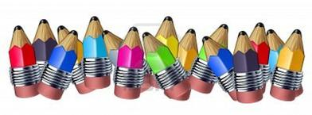

- 1 backpack
- 1 1in - 3 ringed binder
- 3 pocket folders (just holes, no prongs)
- 1 art box
- 1 pair of scissors
- 1 pair of either earbuds or headphones
- 1 box crayons (8 count)
- 1 box markers
- 4 glue sticks
- 2-3 boxes of Kleenex
- 3 containers of Lysol/Clorox cleaning wipes
- 1 box of sandwich sized Ziploc or Slider bags
- 1 box of gallon sized Ziploc or Slider bags
- 1 toothbrush
- 1 tube of toothpaste
- Snacks for your child only (we will have a daily snack time)
- 1 change of clothes to keep at school (for minor accidents with food, etc.)

- Diapers/Pullups (if needed)
- Wipes (if needed)
