5th/6th Grade CIP Supply List
Miss Kessler’s Class
6 – Elmer’s glue sticks
3 – boxes of tissues
1 – box of Crayola crayons 24 ct
1 – box of sandwich or gallon baggies
3 – containers Clorox wipes
1 – Crayola Markers 8 ct
1 – liquid hand soap refill
4 – dry erase markers
1 pair of earbuds or headphones (only item labeled with name)
A change of clothes (pants, shirt, underwear, and socks)
Toileting needs if necessary (pull ups, diapers, wipes, etc)

Optional – 1 spiral bound notebook for classroom journal.
**You do not have to label school supply items with your child’s name. They will be placed into tubs for each item and will be shared!**
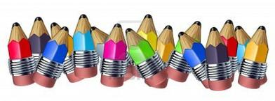
You do NOT need a crayon box, pencils, scissors, binders, or folders.

