July 11, 2017

CONTACT: Nate Davis
Assistant Superintendent
nsdavis@msddecatur.k12.in.us

Decatur Central Traffic Flow and Drop-Off Changes

Decatur Central High School Students, Parents, Staff and Community:

In the MSD of Decatur Township, student safety is our single most important priority. With that being part of our mission, we wanted to communicate some changes to our parking and drop-off process at Decatur Central High School. Starting immediately, we now have a designated student drop/off, visitor and pick up area located on the northwest side of Door One. Drivers will no longer be permitted to drop off/pick up in the fire lane in front of door one. Another option for pick up/drop off is Door 10, on the South side of the building. We believe this will provide the highest level of safety and traffic flow for our families.

We invite you to review the images below for clarification.

Thanks for your cooperation.

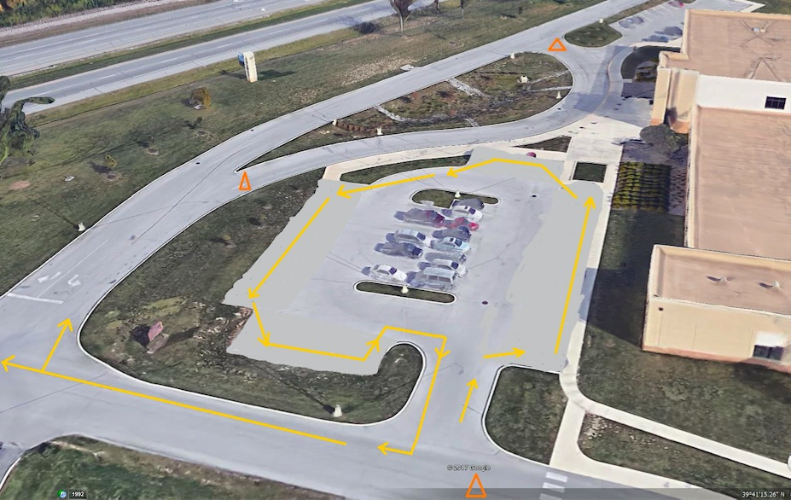
.
No through traffic at pick-up/drop-off
Guest parking only- no staff or student parking, or pick up/drop off
Staff only parking
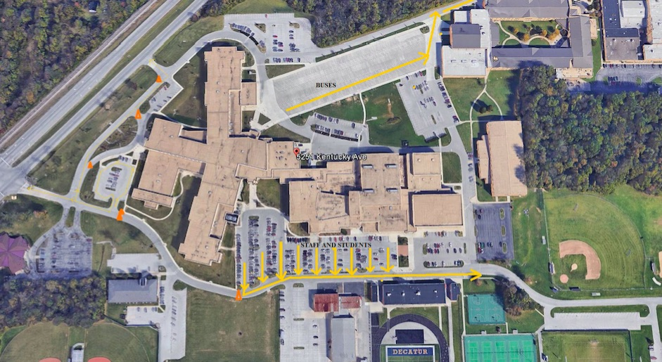
STAFF AND STUDENT PARKING; ENTER DOOR 10
Door 10 TRAFFIC FLOW
EXIT TRAFFIC TO HIGH SCHOOL ROAD ONLY; NO EXIT TRAFFIC TO KY AVE.

