August 26, 2016
5275 Kentucky Avenue
Indianapolis, IN 46221

317.856.5265
317.856.2156
www.msddecatur.k12.in.us
pp
F

pp
P

Dear Parents/Guardians,
As a District, we have adopted a new math program, enVisionmath2.0 © This is a comprehensive, blended digital and print mathematics program designed to help your child achieve the mathematical proficiency levels established by the District, providing the foundation for future math courses and beyond.
Your child will be actively involved in using concrete and digital tools to develop deep mathematics understanding and will apply this understanding through practice and problem- solving in every math lesson. In addition, you can expect your child to learn and practice new math ideas and concepts in a variety of ways, such as:
- Solving problems and explaining their thinking in a write-in text and online.
- Using online animations to help build understanding in a visual way.
- Working individually, in pairs, and in small groups to solve problems and share their thinking.
- Completing homework that promotes computational thinking, fluency, and application through rich problem solving.
- Engaging in online practice that provides help as needed through worked-out examples and self-help videos.
- Experiencing a variety of math activities that include Math Games, Math and Science Activities, and Today’s Challenge in order to apply understanding in different contexts and different levels of learning.
Our District is very excited about implementing enVisionmath2.0 and looks forward to working in partnership with you in a successful year in math!
Attached you will find detailed directions on how to access the program online, in order to sign-in using your child’s username and password.
Sincerely,
The District Math Team

Accessing enVisionmath2.0
- Go to the Decatur Township website – www.decaturproud.org
- Click on Departments at the top of the page, then select Academics
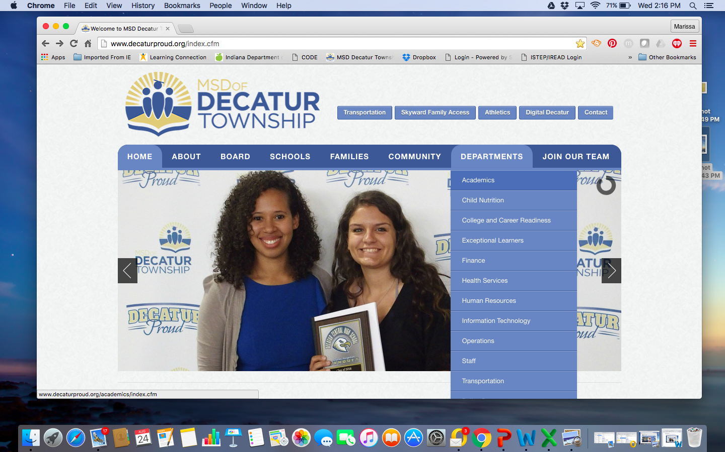

- Click on Pearson at the bottom of the page
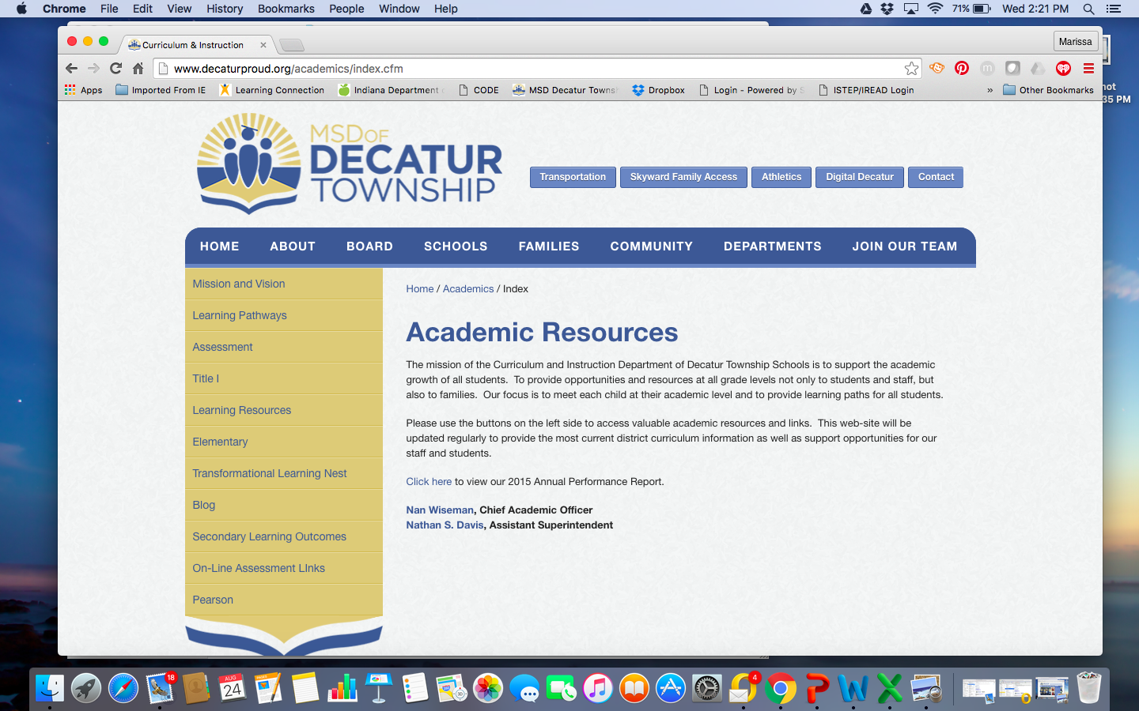

- Enter the Username and Password for your child.
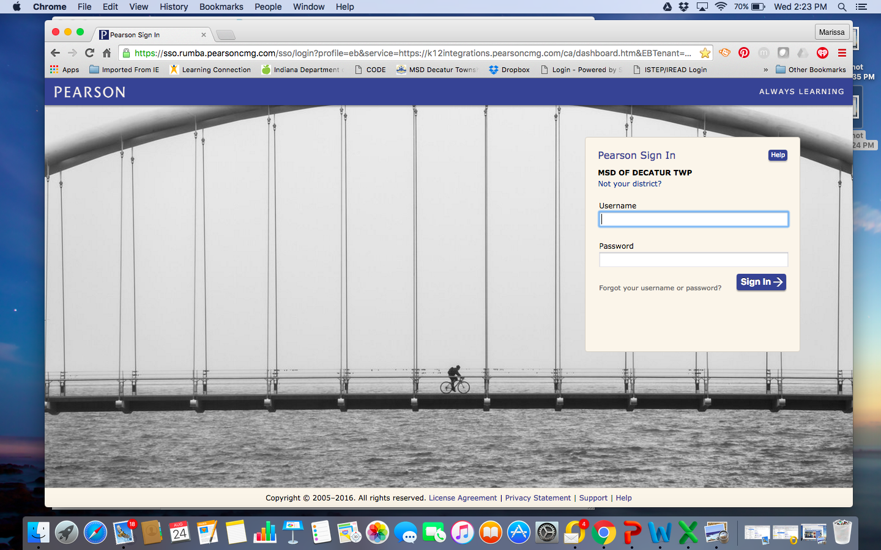

- Click on Pearsonrealize on the right of the page
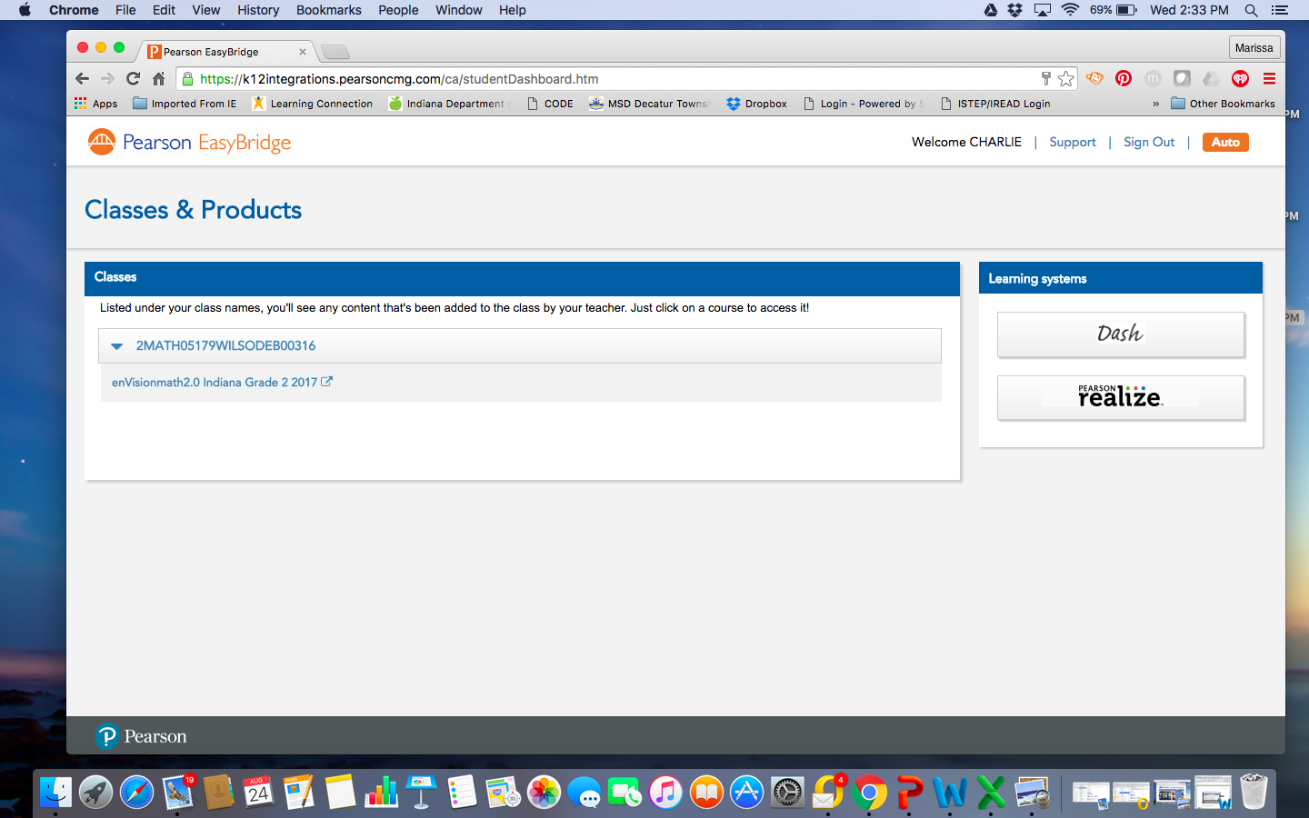

- Click on Programs
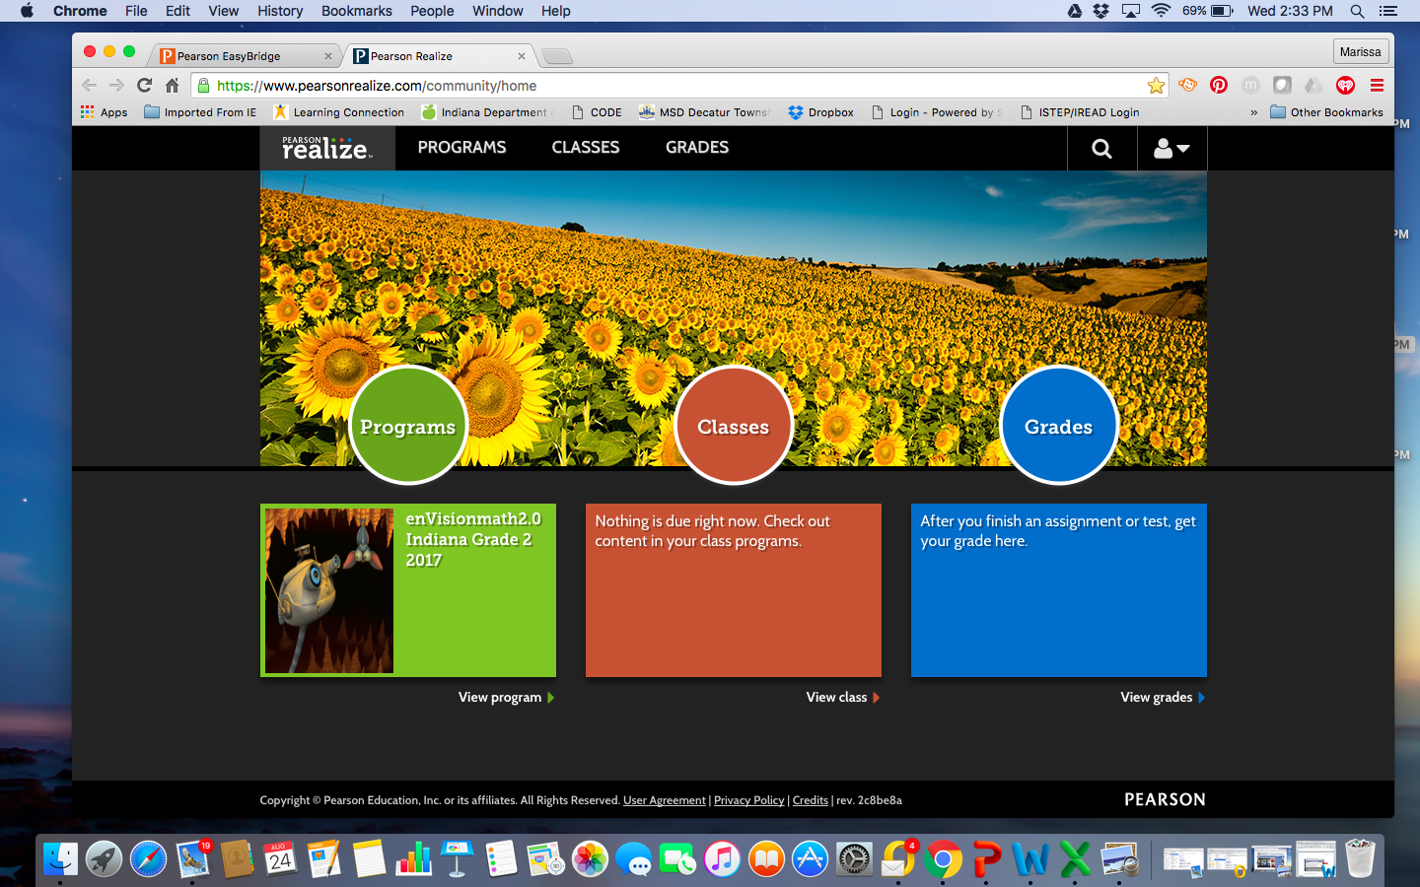

- From here you can select the Topic and Lesson that your child is working on. You will have access to: Student Online Textbook, Another Look Videos, and Math Games for each lesson.

Student Username ___________________________________
Student Password ___________________________________

